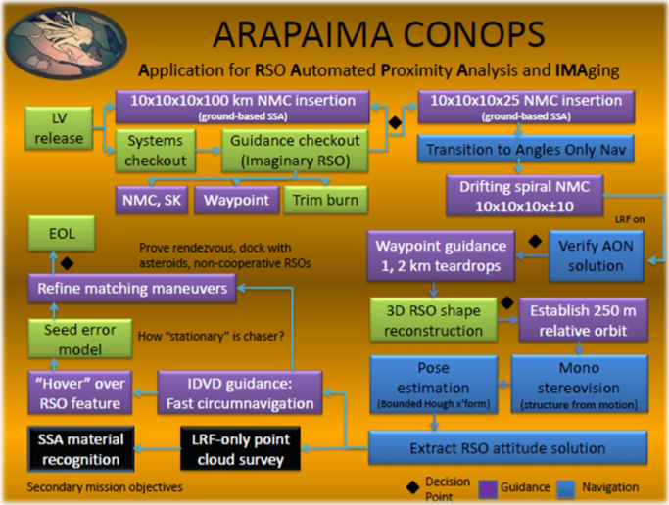
Application for RSO Automated Proximity Analysis and Imaging (ARAPAIMA)

The spacecraft are being developed by Embry-Riddle Aeronautical University, University of Arkansas, and Red Sky Research LLC. It is Embry's entry into the University Nano-Satellite Program Nano-Sat 8. Embry is serving as the prime contractor, Arkansas is developing the propulsion, and Red Sky is providing support for the science of the mission. ARAPAIMA is a 6U spacecraft that will autonomously maneuver into close proximity to a resident space object fro visible, IR,and 3D imaging. The spacecraft uses one 100mN engine for orbit maneuvering and eight 10mN engines for reaction control. Propellant is HFC-236fa with an Isp of 47 seconds. It uses reaction wheels, a star-tracker, GPS receiver, and an inertial measurement unit for attitude determination and control. Power is provided by deploy-able and body solar panels. The payload consists of a laser range finder, SWIR camera, and a monochrome camera. Up-link is UHF and down-link is S-band.
The concept of operations start it the deployment of the spacecraft. The solar panels are partially deployed. Then it detumbles and acquires the sun. The solar panels are completely deployed so the payload can be exposed. It under goes orbit and system checkout. Then it approaches the selected resident space object after attitude determination and control systems and propulsion have been verified. The mission the enters science operations, see figure below for details.

